Team recorder

Discord

3th May, 2021

04:00pm to 07:00pm

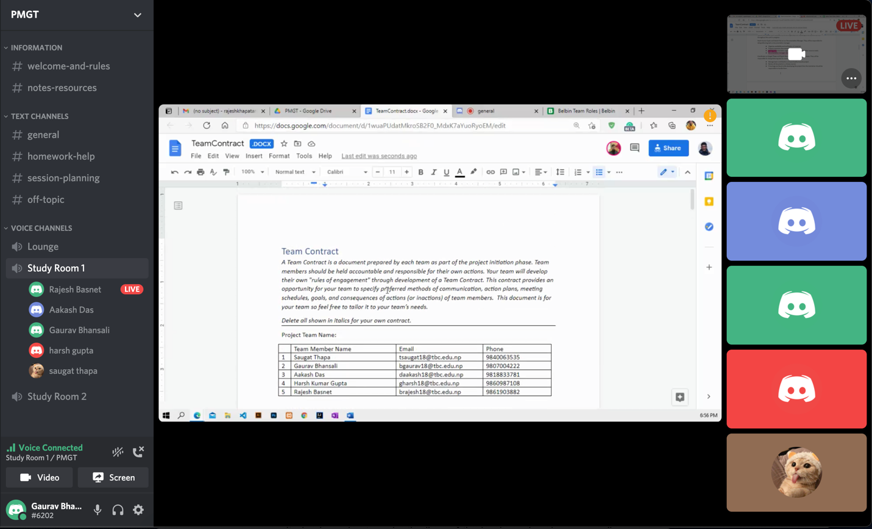

Present today:

Rajesh Basnet

Aakash Das

Gaurav Bhansali

Saugat Thapa

Harsh Gupta

Work done:

Project charter completed.

Roles were distributed.

Team contract started.

On 4th may, 2021

2:00pm to 7:00pm

Present today:

Rajesh Basnet

Aakash Das

Gaurav Bhansali

Saugat Thapa

Harsh Gupta

**Work done:**

Team contract almost completed.

On 5th May, 2021

3:00pm to 4:30pm

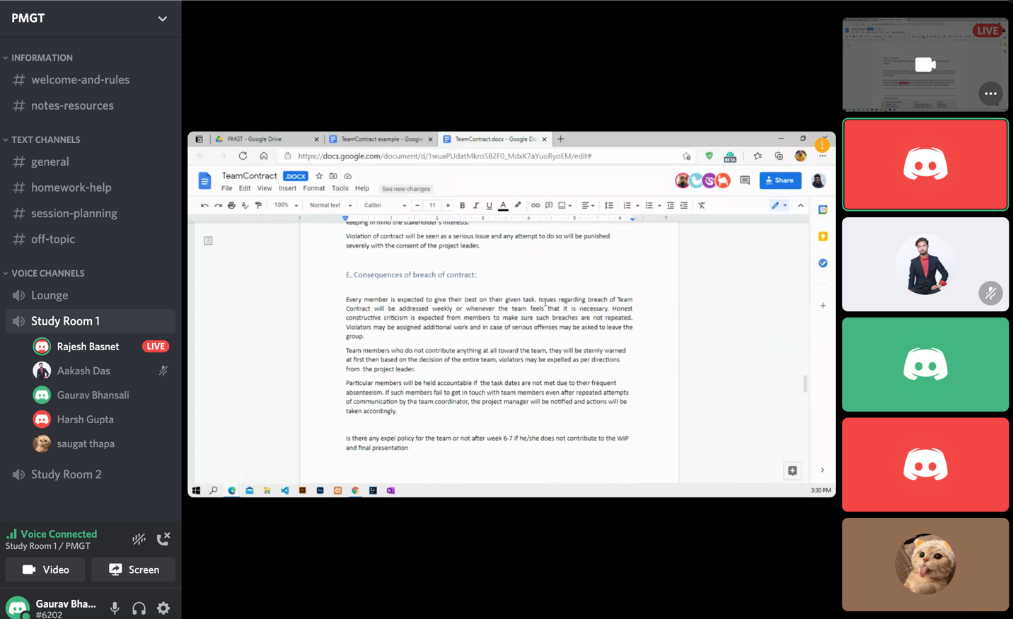

Present today:

Rajesh Basnet

Aakash Das

Gaurav Bhansali

Saugat Thapa

Harsh Gupta

Work done:

Team Contract completed.

On 6th May, 2021

4:00pm to 7:00pm

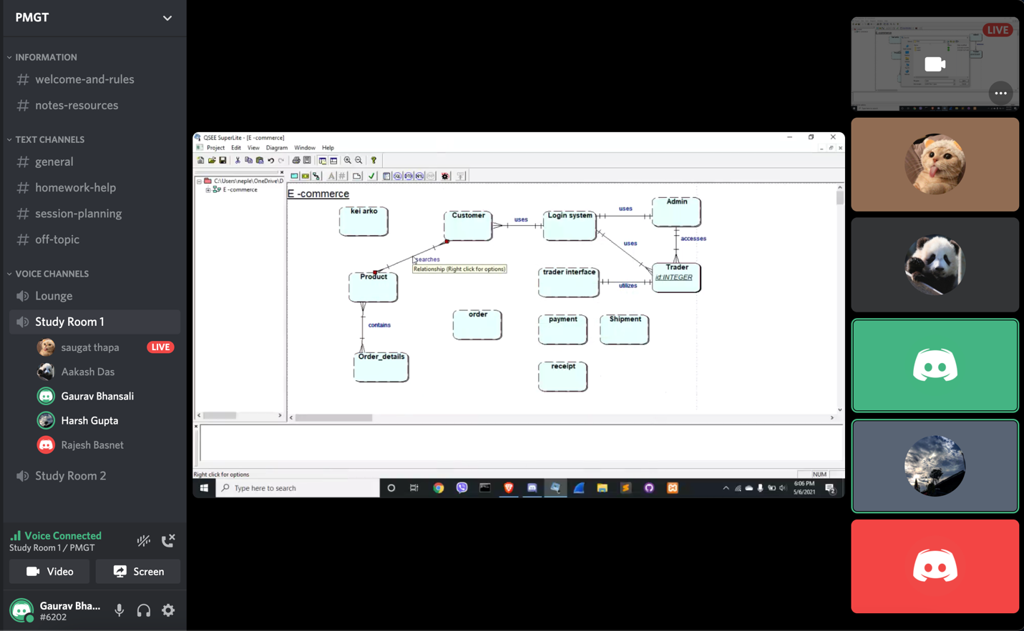

Present today:

Rajesh Basnet

Aakash Das

Gaurav Bhansali

Saugat Thapa

Harsh Gupta

**Work done:**

ER Diagram started

On 7th May,2021

4:10pm to 6:50pm

Present today:

Rajesh Basnet

Aakash Das

Gaurav Bhansali

Saugat Thapa

Harsh Gupta

**Work done:**

ER diagram completed.

EER diagram started.

Week 2

On 9th May,2021

4:10pm to 6:20pm

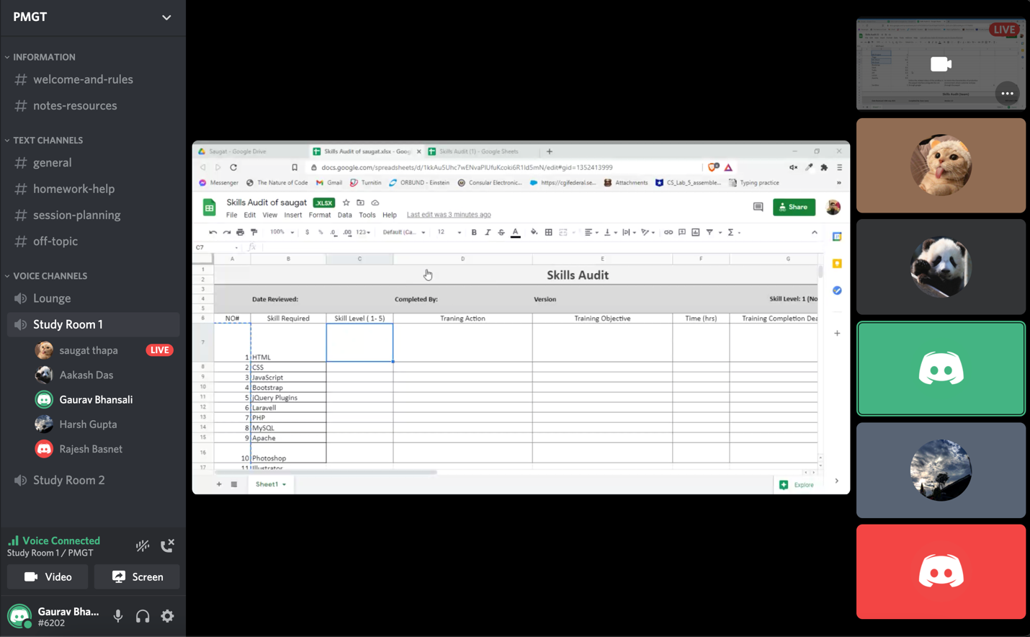

Present today:

Rajesh Basnet

Aakash Das

Gaurav Bhansali

Saugat Thapa

Harsh Gupta

**Work done:**

Skills Audit started.

EER diagram completed.

UseCase diagram started. (UML)

On 10th May,2021

4:00pm to 6:00pm

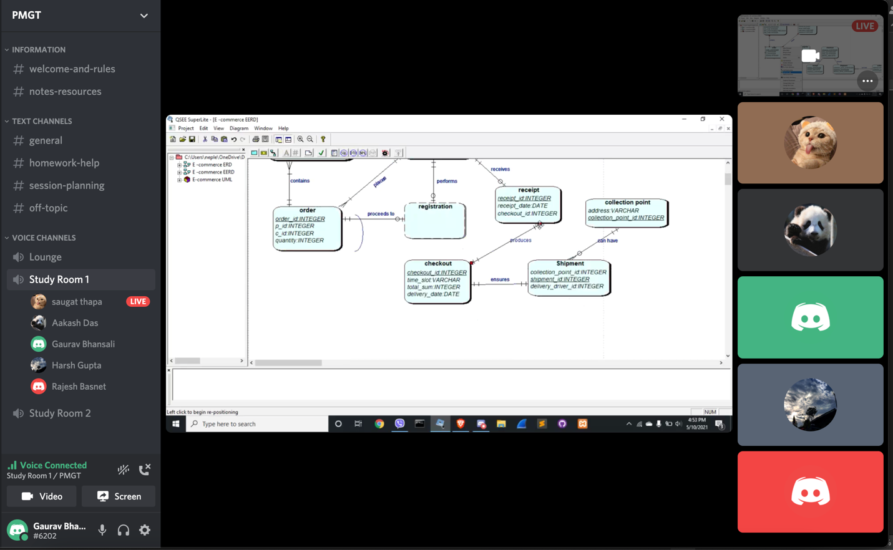

Present today:

Rajesh Basnet

Aakash Das

Gaurav Bhansali

Saugat Thapa

Harsh Gupta

**Work done:**

UseCase Diagram completed. (UML)

On 11th May,2021

4:00pm to 6:35pm

Present today:

Rajesh Basnet

Aakash Das

Gaurav Bhansali

Saugat Thapa

Harsh Gupta

**Work done:**

Skills Audit work-in progress.

On 12th May,2021

4:00pm to 6:00pm

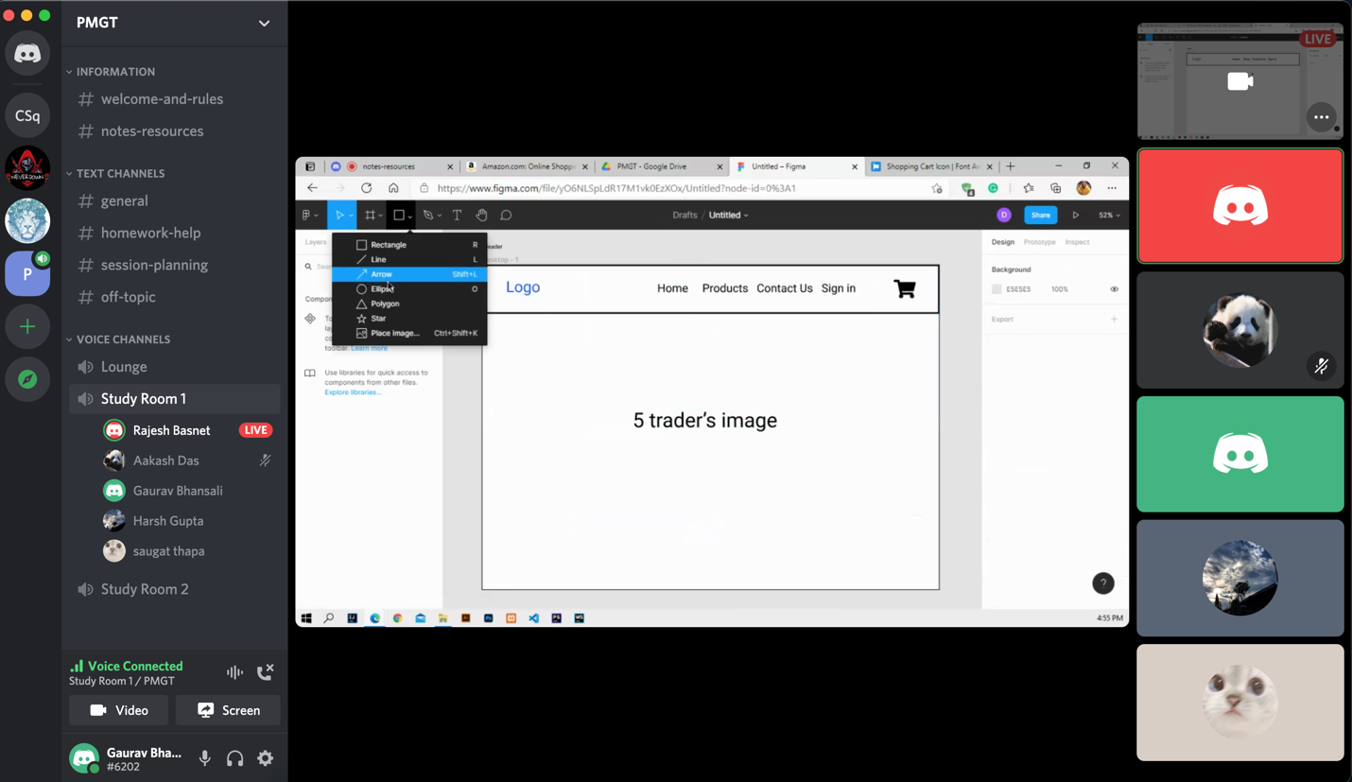

Present today:

Rajesh Basnet

Aakash Das

Gaurav Bhansali

Saugat Thapa

Harsh Gupta

**Work done**:

Skills Audit completed.

Wireframe discussion using Figma.

On 13th May, 2021

4:00pm to 5:30pm

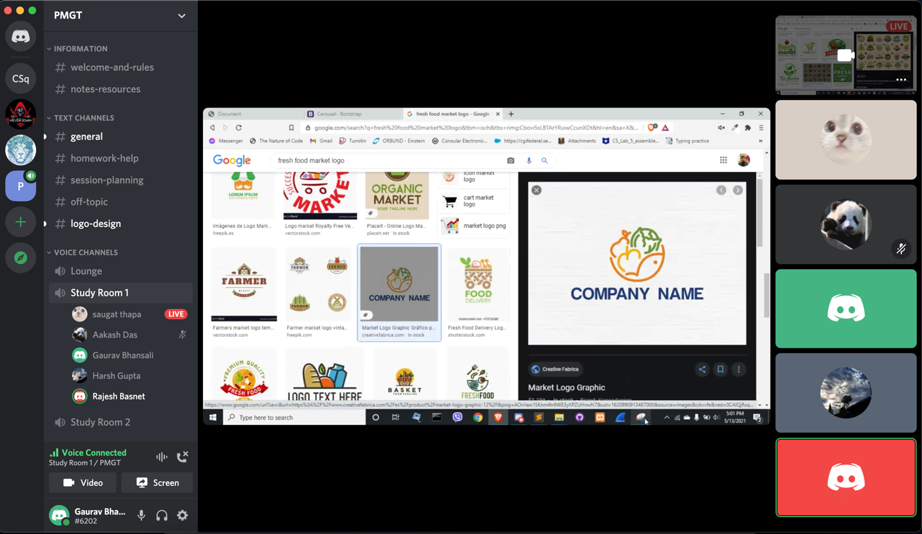

Present today:

Rajesh Basnet

Aakash Das

Gaurav Bhansali

Saugat Thapa

Harsh Gupta

**Work done:**

Selection of logo.

Wireframe discussion.

On 14th May, 2021

4:00pm to 5:00pm

Present today:

Rajesh Basnet

Aakash Das

Gaurav Bhansali

Saugat Thapa

Harsh Gupta

**Work done:**

Wireframe discussion.

On 16th May, 2021

4:00pm to 6:30pm

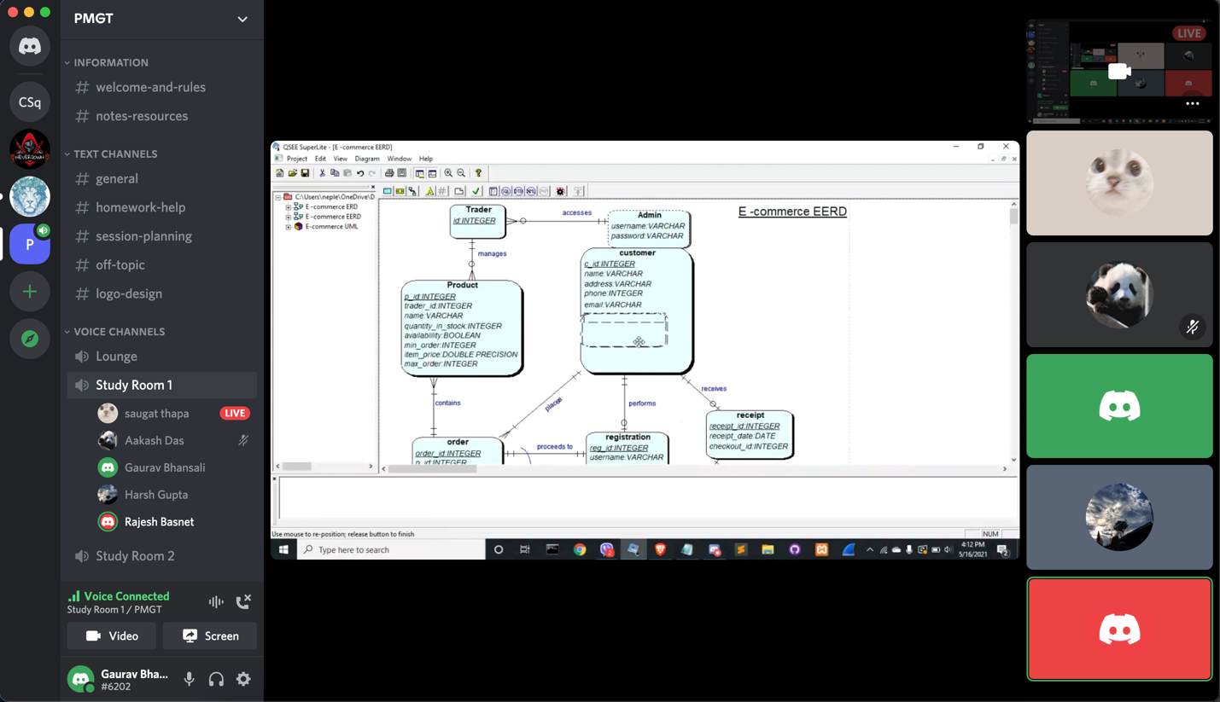

Present today:

Rajesh Basnet

Aakash Das

Gaurav Bhansali

Saugat Thapa

Harsh Gupta

**Work done:**

ER diagram modification.

EER diagram modification.

On 17th May, 2021

3:00pm to 6:00pm

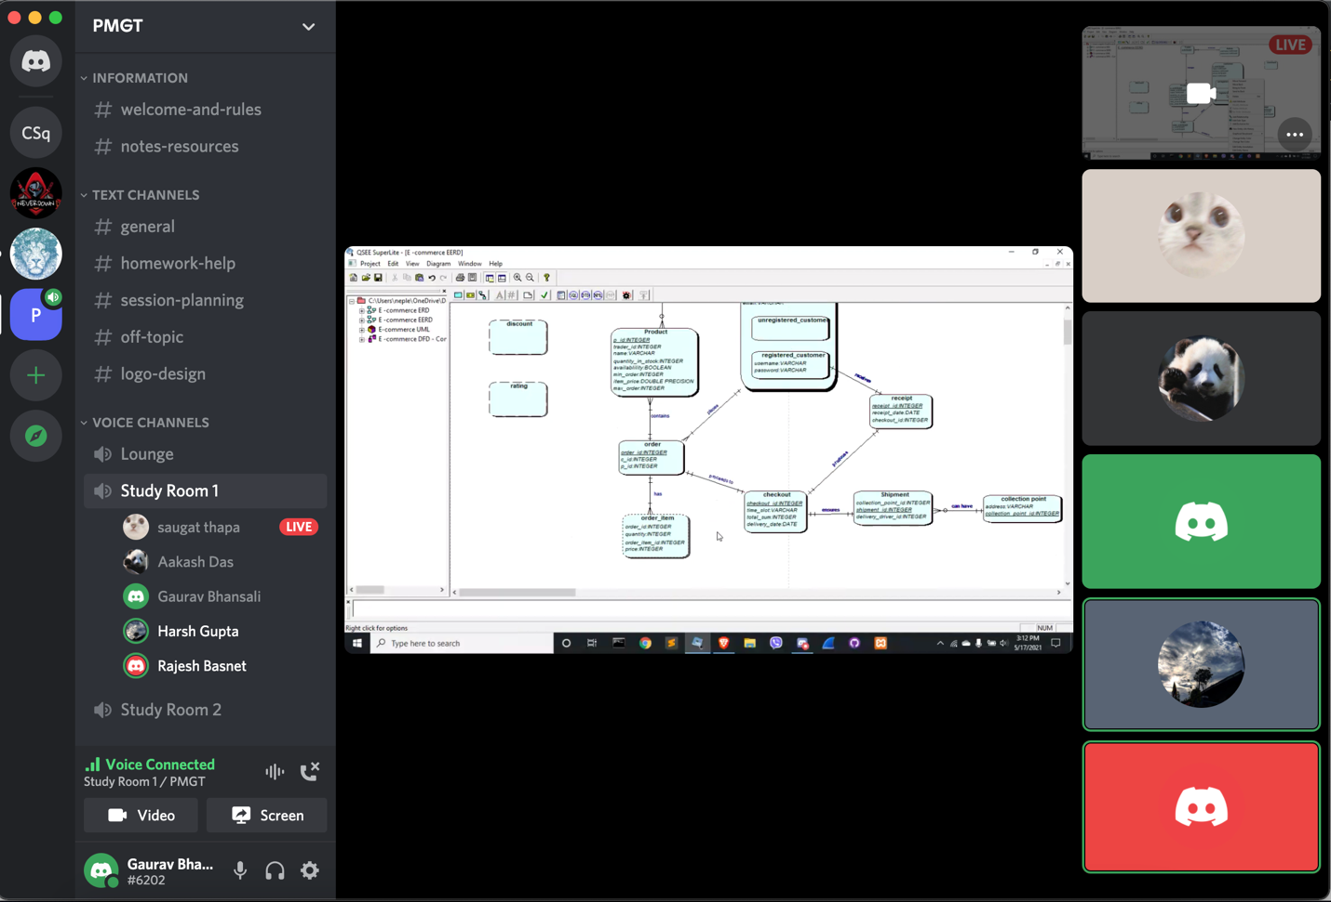

Present today:

Rajesh Basnet

Aakash Das

Gaurav Bhansali

Saugat Thapa

Harsh Gupta

**Work done:**

ER diagram version 1 completed.

EER diagram version 1 completed.

Logical table version 1 completed.

On 24th May, 2021

4:00pm to 6:45pm

Present today:

Rajesh Basnet

Aakash Das

Gaurav Bhansali

Saugat Thapa

Harsh Gupta

**Work done:**

Admin Use Case created.

Trader Use Case created.

Management Use Case created.

Wireframe work-in progress.

On 27th May, 2021

3:00pm to 5:15pm

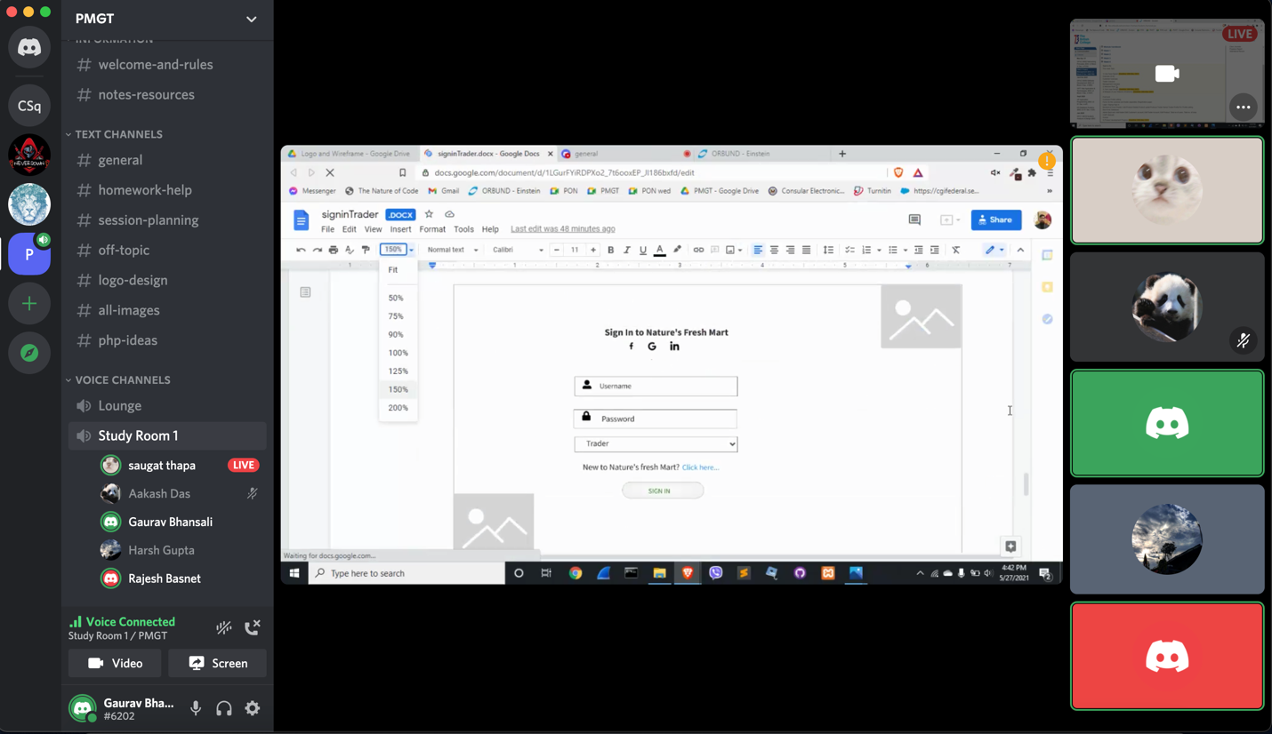

Present today:

Rajesh Basnet

Aakash Das

Gaurav Bhansali

Saugat Thapa

Harsh Gupta

**Work done:**

Wireframe discussion.

Mockup discussion.

On 30th May, 2021

3:00pm to 7:00pm

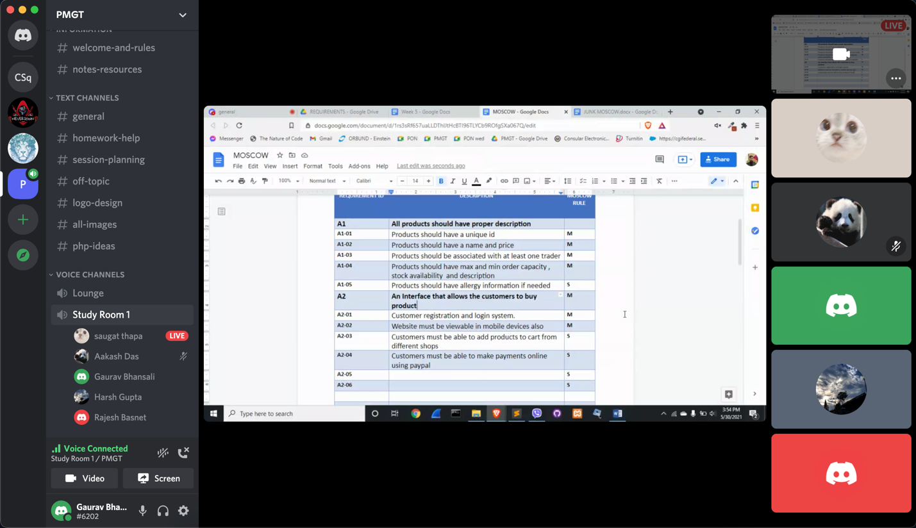

Present today:

Rajesh Basnet

Aakash Das

Gaurav Bhansali

Saugat Thapa

Harsh Gupta

**Work done:**

Production Development completed.

MoSCoW rule started.

On 7th June,2021

4:00pm to 4:45pm

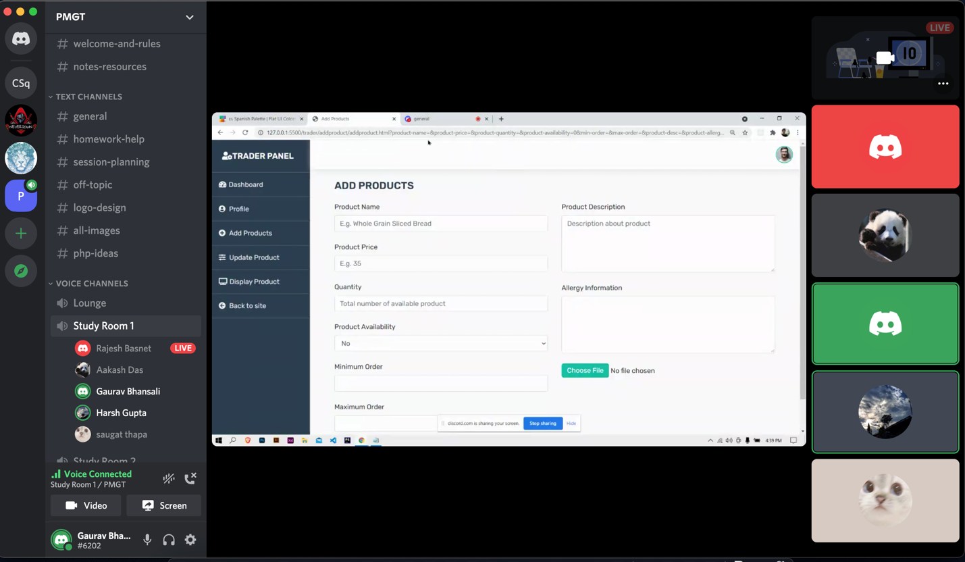

Present today:

Rajesh Basnet

Aakash Das

Gaurav Bhansali

Saugat Thapa

Harsh Gupta

Work done:

Trader panel work started.

Work-in progress documentation started.

**Demo presentation and submission13thjune to 15thjune**

Meet link:

https://meet.google.com/kzu-jyhw-kre?pli=1&authuser=3

Date : 19th June 2021 onwards started working on backend by distributing everyone respective work

So the meeting timing was random (only when we faced any trouble)

oci and paypal instruction given by tutor (20thJune onwards)

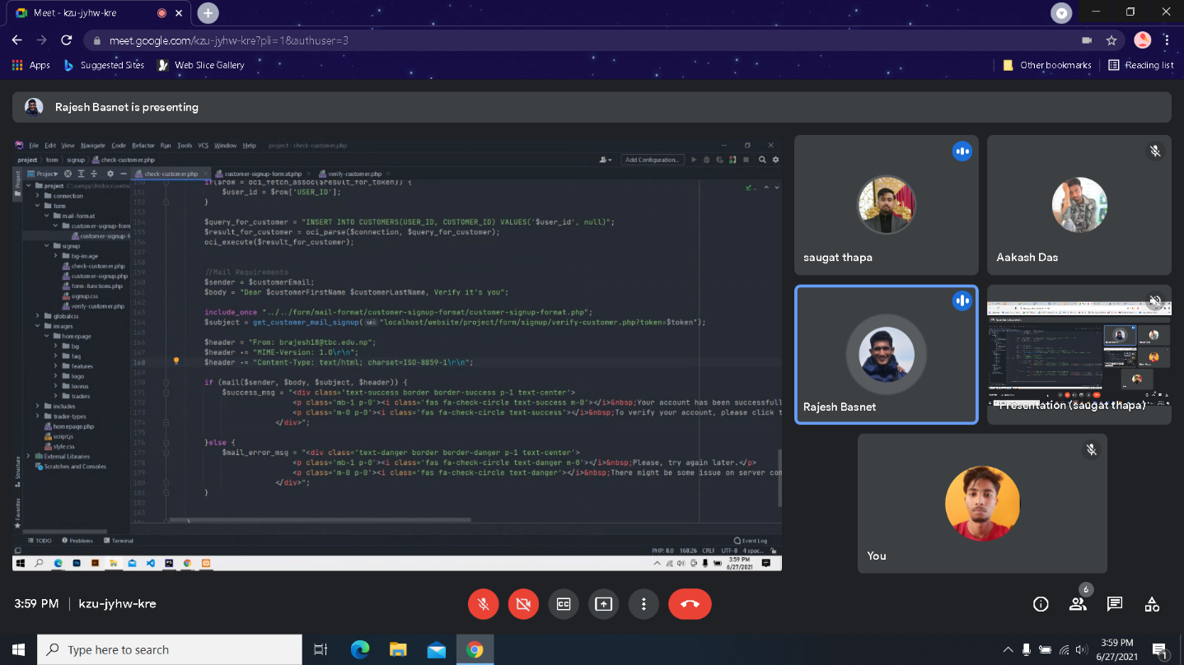

Work done:

Discussion on customer signup and verification

Date:20th June 2021

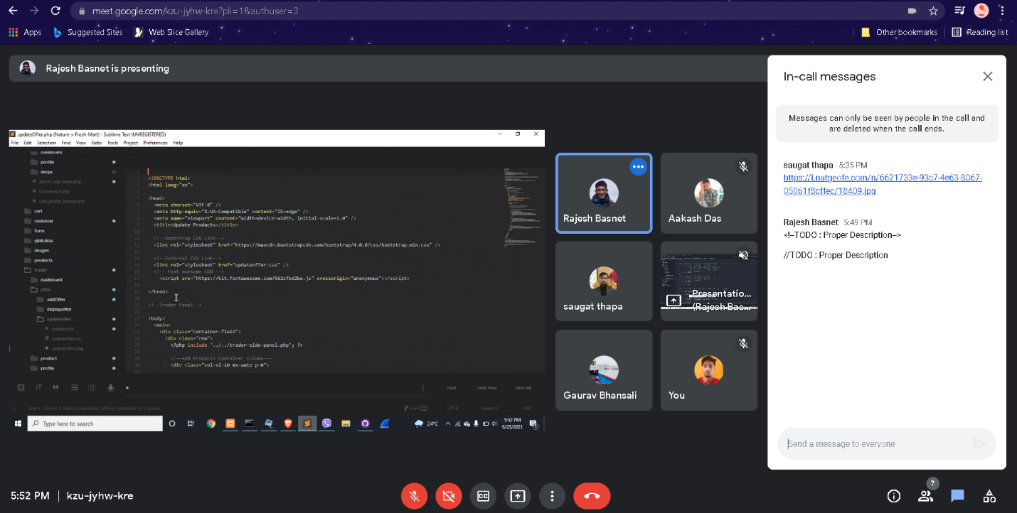

Work done:

Fixed some basic error in offer section

Present: Rajesh, Aakash,Saugat,Harsh,Gaurav

22nd June 2021

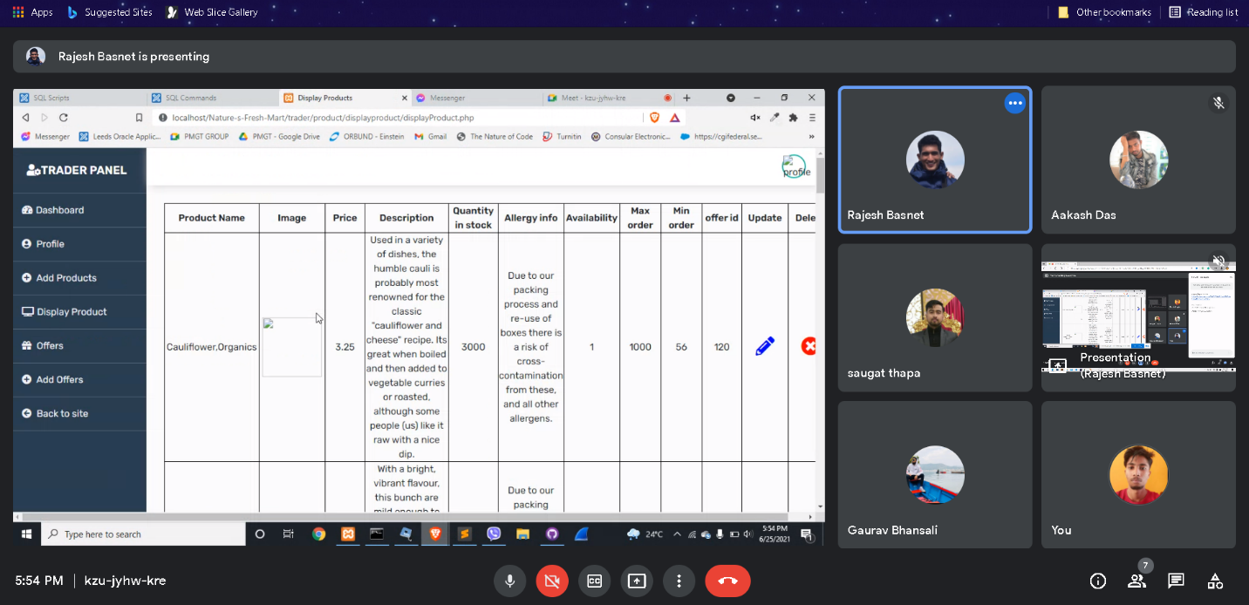

Present: Rajesh, Aakash,Saugat,Harsh,Gaurav

Crud functionality error solving

Further discussion on crud functionality

Making some changes in frontend (pictures)

28th June 2021

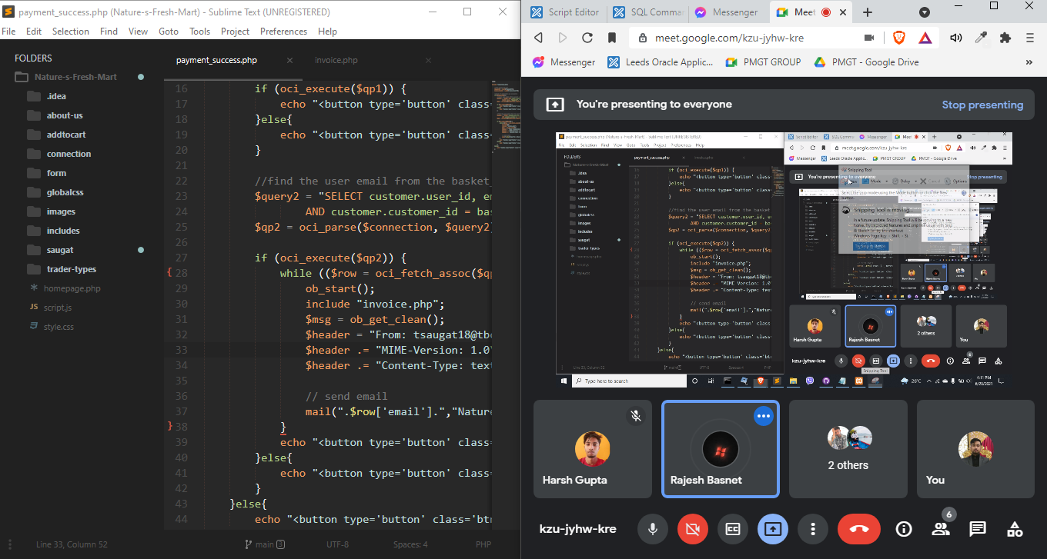

Work done:

Discussion and solving error in PayPal functions

Present: Rajesh, Aakash, Saugat, Harsh, Gaurav

Final Portfolio started from 28th June

Further discussions on bugs and any changes need to be made

